7.

#question 7 - LIST PROGRAM

def menu():

print("\n \t\t =========================")

print("\t\t\t MENU : ")

print("\t1- Find the length of the string")

print("\t2- Find the maximum of three strings")

print("\t3- Find the string and replace vowels with #")

print("\t4- Find the number of words in a given string")

print("\t5- Check if string is a palindrome or not")

print("\t\t =========================")

def maxOfStrings(a,b,c):

if (a.isdigit() and b.isdigit()and c.isdigit):

max=a

if (b>max):

max=b

if (c>max):

max=c

return max

else:

max=len(a)

l2=len(b)

l3=len(c)

if (l2>max):

max=b

if (l3>max):

max=c

else:

max=a

return max

if (max==l2==l3):

if (a>b and a>c):

max=a

elif (b>a and b>c):

max=b

elif (c>a and c>b):

max=c

return max

else:

return max

def replaceVowels(a):

new=""

for i in a:

if (i=='a' or i=='e' or i=='o' or i=='i' or i=='u'):

new+="#"

else:

new+=i

return new

def countWords(a):

count=0

for i in a:

if (i==" " or i=="\t" or i=="\n" or i=="r"):

count+=1

return count

def pallindromeTest(str):

for i in range(0, int(len(str)/2)):

if str[i] != str[len(str)-i-1]:

return False

return True

ch="y"

while(ch=='y' or ch=="Y"):

menu()

choice=int(input("\n -> Enter your choice from the menu : "))

if (choice==1):

print("\n\t OPERATION CHOOSEN : LENGTH OF THE STRING \n")

str_input=input("Enter the string : ")

lngth=len(str_input)

print("--> Length of the string - " , lngth)

elif (choice==2):

print("\n\t OPERATION CHOOSEN : MAXIMUM OF THREE STRINGS \n")

str1=input("Enter the first string : " )

str2=input("Enter the second string : " )

str3=input("Enter the third string : " )

str_max=maxOfStrings(str1,str2,str3)

print("--> The maximum of three strings is : ",str_max)

elif (choice==3):

print("\n\t OPERATION CHOOSEN : REPLACE VOWELS WITH # \n")

str_input=input("Enter the string : ")

str_vow=replaceVowels(str_input)

print("-->The new string - " , str_vow)

elif (choice==4):

print("\n\t OPERATION CHOOSEN : COUNT NUMBER OF WORDS \n")

str_input=input("Enter the string : ")

wordCount=countWords(str_input)

print("-->Total number of words in string - " , wordCount)

elif (choice==5):

print("\n\t OPERATION CHOOSEN : PALLINDROME TEST \n")

str_input=input("Enter the string : ")

result=pallindromeTest(str_input)

if (result):

print("--> The string " ,str_input, " is a pallindrome")

else:

print("--> The string " ,str_input, " is not a pallindrome")

else:

print("\n ** ERROR : ENTER A VALID CHOICE ***\n")

ch=input("\n -> Do you want to continue (y/n) : ")

print(" \t \t PROGRAM ENDS HERE ")

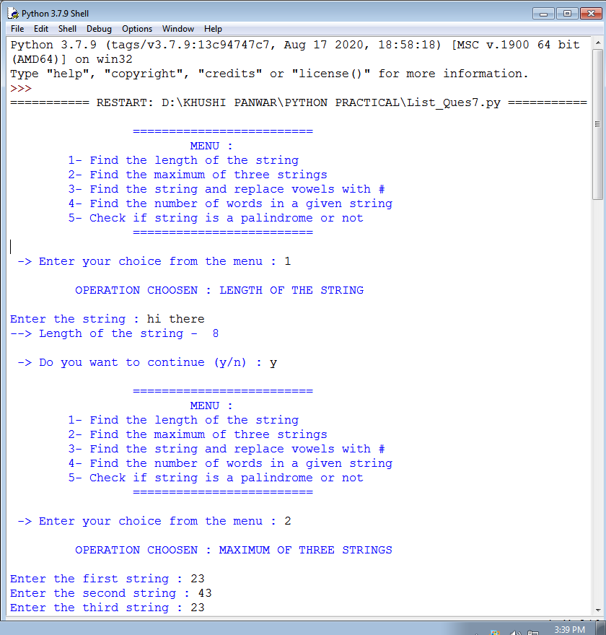

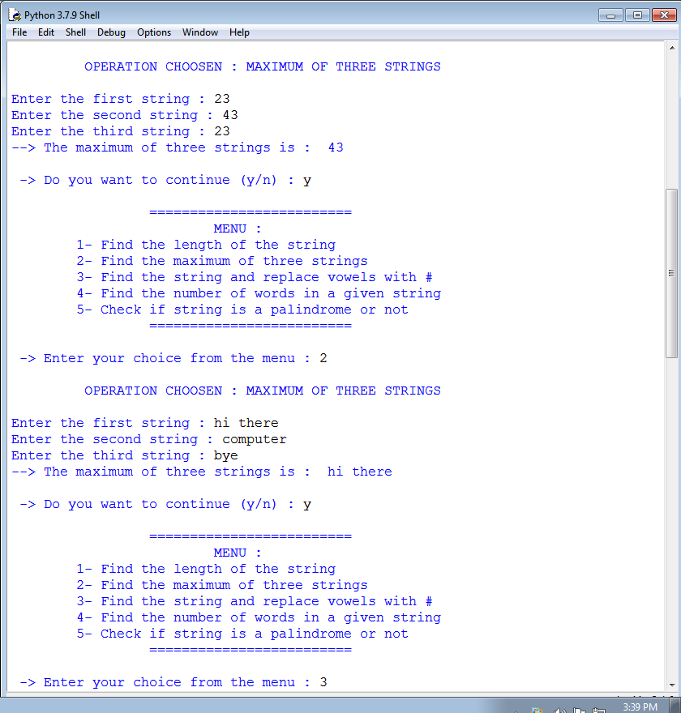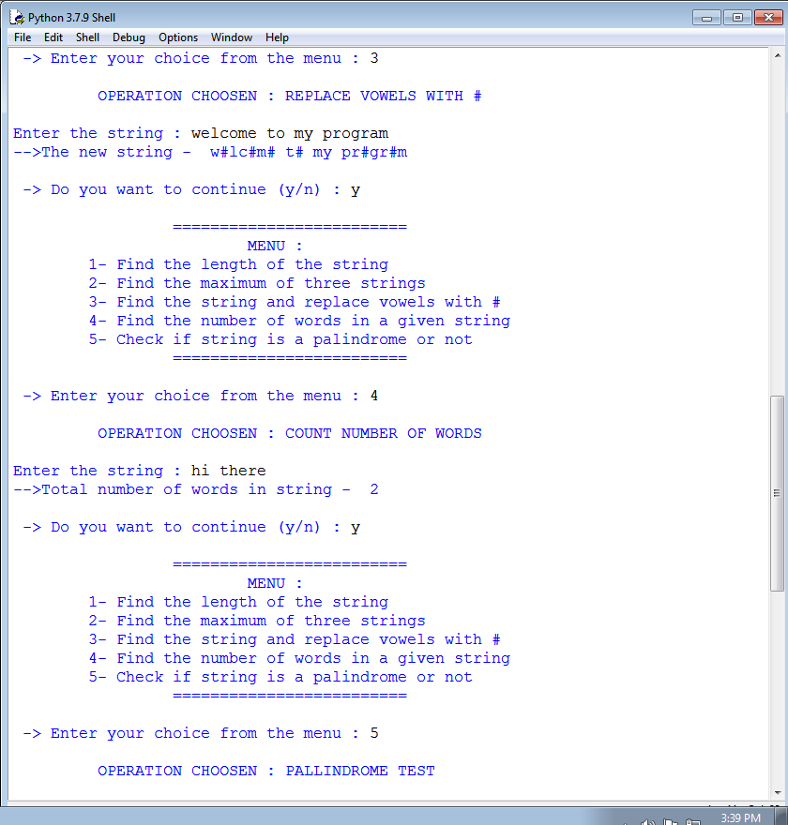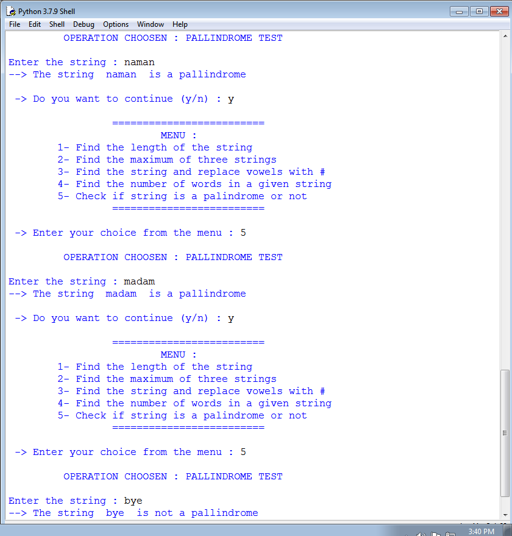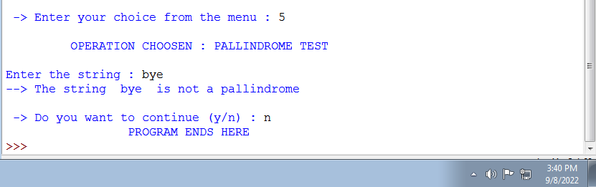

8.

#QUESTION 8 - LIST PROGRAM

def menu():

print("\n \t\t =========================")

print("\t\t\t THIS PROGRAM PERFORMS FOLLOWING TASKS : ")

print("\t1- Check if all elements in list are numbers or not")

print("\t -> If it is a numeric list, then count number of odd values in it ")

print("\t -> If list contains all strings, then display largest String in the list")

print("\t2- Display list in reverse form")

print("\t3- Find a specified element in list")

print("\t4- Remove the specified element from the list")

print("\t5- Sort the list in descending order")

print("\t6- Accept 2 lists and find the common members in them")

print("\t\t =========================")

def commonListMembers(lst1, lst2):

min=len(lst1)

l2=len(lst2)

if (l2<min):

min=l2

commonList=[]

for i in lst1:

for j in lst2:

if i==j:

commonList.append(i)

return commonList

def listType(lst):

for i in lst:

if (i.isdigit==False):

return False

return True

def oddValCount(lst):

count=0

for i in lst:

if (i%2!=0):

count+=1

return count

def maxString(lst):

maxLen=0

for i in lst:

if (len(i)>=maxLen):

maxLen=len(i)

result=i

return result

def listReverse(a):

a.reverse()

return a

def listSearch(num, lst):

flag=0

for i in range(len(lst)):

if (lst[i]==num):

flag+=1

index=i

if (flag>0):

print("--> ", num, " found at " , index, " index in the list! " )

else:

print("--> ", num, " not found in the given list")

def listRemove(num,lst):

flag=0

for i in range(len(lst)):

if (lst[i]==num):

lst.remove(lst[i])

index=i

if (flag>0):

print("--> ", num, " removed from the list at index " , index, "\n THE NEW LIST : ", lst )

else:

print("--> ERROR REMOVING THE ELEMENT :: \t", num, " not found in the given list.")

ch="y"

while(ch=='y' or ch=="Y"):

menu()

lst_input1=list(map(str, input("Enter the list elements here : ").split()))

print("- The list entered : ", lst_input1)

lst_input=[int(x) for x in lst_input1]

choice=int(input("\n -> Enter your choice from the menu : "))

if (choice==1):

print("\n\t OPERATION CHOOSEN : CHECK LIST ELEMENT TYPE \n")

result=listType(lst_input1)

if (result):

print("--> The List is numerical !")

oddCount=oddValCount(lst_input)

print("--> The total number of odd values in list are ", oddCount)

else:

print("--> The List is not numerical !")

max_string=maxString(lst_input1)

print("--> The maximum/largest string from the list is ", max_string)

elif (choice==2):

print("\n\t OPERATION CHOOSEN : LIST IN REVERSE FORM \n")

lst_rev=listReverse(lst_input)

print("--> The Reversed List is : ", lst_rev)

elif (choice==3):

print("\n\t OPERATION CHOOSEN : SEARCH SPECIFIED ELEMENT \n")

num=input("Enter the element to be searched : ")

listSearch(num, lst_input)

elif (choice==4):

print("\n\t OPERATION CHOOSEN : REMOVE SPECIFIED ELEMENT \n")

num=input("Enter the element to be removed : ")

listRemove(num, lst_input)

elif (choice==5):

print("\n\t OPERATION CHOOSEN : SORT LIST IN DESCENDING ORDER \n")

rev=listReverse(lst_input)

print("--> The Reversed List is ", rev)

elif (choice==6):

print("\n\t OPERATION CHOOSEN : COMMON MEMBERS FROM 2 LISTS \n")

lst_input2=list(map(str, input("Enter the list elements here : ").split()))

print("- The 2nd list entered : ", lst_input1)

commonList=commonListMembers(lst_input1, lst_input2)

print("--> The Common Members of the lists are ", commonList)

else:

print("\n ** ERROR : ENTER A VALID CHOICE ***\n")

ch=input("\n -> Do you want to continue (y/n) : ")

print(" \t \t PROGRAM ENDS HERE ")

8.

#QUESTION 8 - LIST PROGRAM

def menu():

print("\n \t\t =========================")

print("\t\t\t THIS PROGRAM PERFORMS FOLLOWING TASKS : ")

print("\t1- Check if all elements in list are numbers or not")

print("\t -> If it is a numeric list, then count number of odd values in it ")

print("\t -> If list contains all strings, then display largest String in the list")

print("\t2- Display list in reverse form")

print("\t3- Find a specified element in list")

print("\t4- Remove the specified element from the list")

print("\t5- Sort the list in descending order")

print("\t6- Accept 2 lists and find the common members in them")

print("\t\t =========================")

def commonListMembers(lst1, lst2):

min=len(lst1)

l2=len(lst2)

if (l2<min):

min=l2

commonList=[]

for i in lst1:

for j in lst2:

if i==j:

commonList.append(i)

return commonList

def listType(lst):

for i in lst:

if (i.isdigit==False):

return False

return True

def oddValCount(lst):

count=0

for i in lst:

if (i%2!=0):

count+=1

return count

def maxString(lst):

maxLen=0

for i in lst:

if (len(i)>=maxLen):

maxLen=len(i)

result=i

return result

def listReverse(a):

a.reverse()

return a

def listSearch(num, lst):

flag=0

for i in range(len(lst)):

if (lst[i]==num):

flag+=1

index=i

if (flag>0):

print("--> ", num, " found at " , index, " index in the list! " )

else:

print("--> ", num, " not found in the given list")

def listRemove(num,lst):

flag=0

for i in range(len(lst)):

if (lst[i]==num):

lst.remove(lst[i])

index=i

if (flag>0):

print("--> ", num, " removed from the list at index " , index, "\n THE NEW LIST : ", lst )

else:

print("--> ERROR REMOVING THE ELEMENT :: \t", num, " not found in the given list.")

ch="y"

while(ch=='y' or ch=="Y"):

menu()

lst_input1=list(map(str, input("Enter the list elements here : ").split()))

print("- The list entered : ", lst_input1)

lst_input=[int(x) for x in lst_input1]

choice=int(input("\n -> Enter your choice from the menu : "))

if (choice==1):

print("\n\t OPERATION CHOOSEN : CHECK LIST ELEMENT TYPE \n")

result=listType(lst_input1)

if (result):

print("--> The List is numerical !")

oddCount=oddValCount(lst_input)

print("--> The total number of odd values in list are ", oddCount)

else:

print("--> The List is not numerical !")

max_string=maxString(lst_input1)

print("--> The maximum/largest string from the list is ", max_string)

elif (choice==2):

print("\n\t OPERATION CHOOSEN : LIST IN REVERSE FORM \n")

lst_rev=listReverse(lst_input)

print("--> The Reversed List is : ", lst_rev)

elif (choice==3):

print("\n\t OPERATION CHOOSEN : SEARCH SPECIFIED ELEMENT \n")

num=input("Enter the element to be searched : ")

listSearch(num, lst_input)

elif (choice==4):

print("\n\t OPERATION CHOOSEN : REMOVE SPECIFIED ELEMENT \n")

num=input("Enter the element to be removed : ")

listRemove(num, lst_input)

elif (choice==5):

print("\n\t OPERATION CHOOSEN : SORT LIST IN DESCENDING ORDER \n")

rev=listReverse(lst_input)

print("--> The Reversed List is ", rev)

elif (choice==6):

print("\n\t OPERATION CHOOSEN : COMMON MEMBERS FROM 2 LISTS \n")

lst_input2=list(map(str, input("Enter the list elements here : ").split()))

print("- The 2nd list entered : ", lst_input1)

commonList=commonListMembers(lst_input1, lst_input2)

print("--> The Common Members of the lists are ", commonList)

else:

print("\n ** ERROR : ENTER A VALID CHOICE ***\n")

ch=input("\n -> Do you want to continue (y/n) : ")

print(" \t \t PROGRAM ENDS HERE ")